Muhammad Umar Farooq : Writing task 1
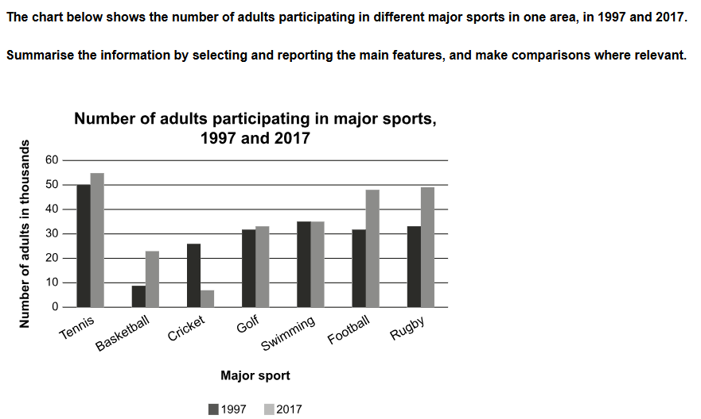
The chart provides information about the trends of participation of adults in significant sports between 1997 and 2017.
Overall, Tennis, Basketball, Football, Golf, and Rugby experienced an upward trend, while Cricket showed a downward trend. Meanwhile, Swimming remained stable throughout the period.
Getting back to the details, Tennis had approximately 50 participants in 1997 and rose to 55 in 2017. However, Basketball had approximately 9 participants in 1997 and jumped to 22 in 2017. In contrast, Golf took a small step forward, rising from 31% in 1997 to 33% in 2017.
Similarly, Football and Rugby were the most popular games over the period from 1997 to 2017. Football stood at approximately 31% in 1997 and rose to 49% in 2017. Rugby also took a significant jump, rising from 32% to 50%.
Swimming was the sport that remained stable, without losing participants over time, and remained steady at 35%.
Cricket was the only sport that showed a downward trend. It had 25% in 1997, but dropped to 8% in 2017.
Cricket was only the game which illustrated a downward trend, it had 25 in 1997, but it dropped to 8 in 2017.

